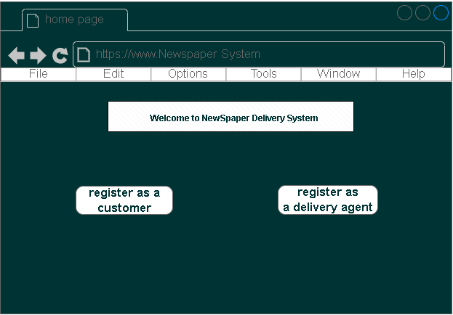

**To use the Newspaper Delivery System, you must first register as a customer or delivery agent. Registration can be done via the system's user interface**

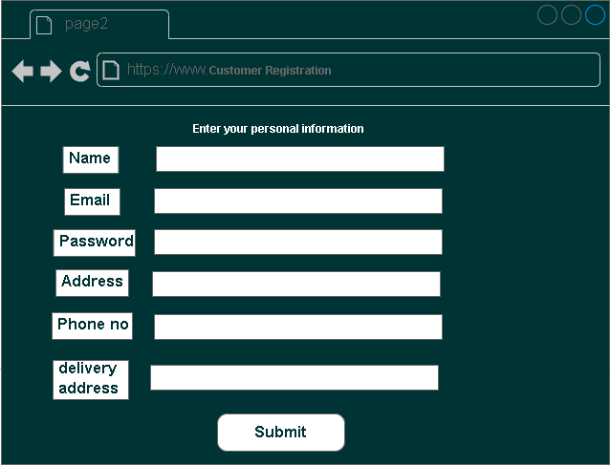

**Customer Registration**

**To register as a customer, click on the "Register" button on the homepage. You will be asked to provide your personal information, including your name, email address, phone number, and delivery address. Once you have provided all the necessary information, click on the "Submit" button to complete the registration process**

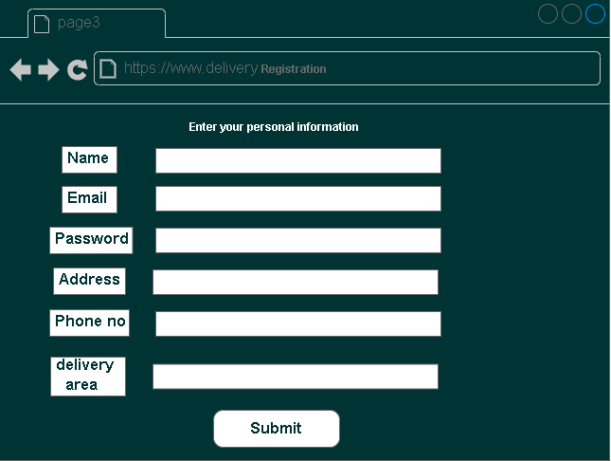

**Delivery Agent Registration**

**To register as a delivery agent, click on the "Register" button on the homepage. You will be asked to provide your personal information, including your name, email address, phone number, and delivery area. Once you have provided all the necessary information, click on the "Submit" button to complete the registration process. You will be notified via email once your registration is approved by the system administrator.**

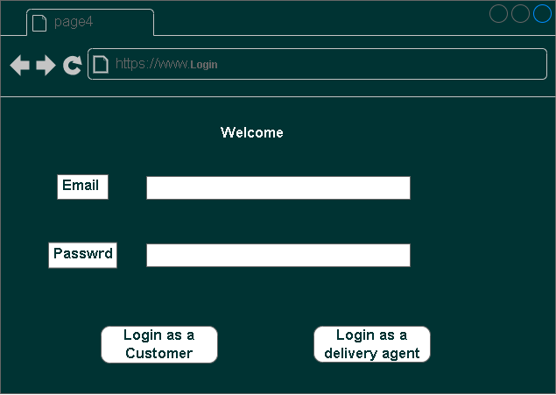

**. You can now log in to the system and view delivery routes and pending deliveries.**

**. You can now log in to the system and place orders for newspapers.**

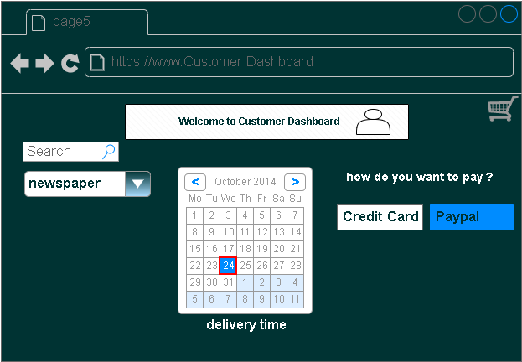

**Placing an Order To place an order**

**log in to the system using your registered email and password. Once you are logged in, you will be directed to the customer dashboard. From here, you can select the newspaper you want to order and choose your delivery preferences, such as the delivery time. You will also be asked to provide your payment information to complete the transaction. Once the order is placed, you will receive a confirmation email with the details of your order.**

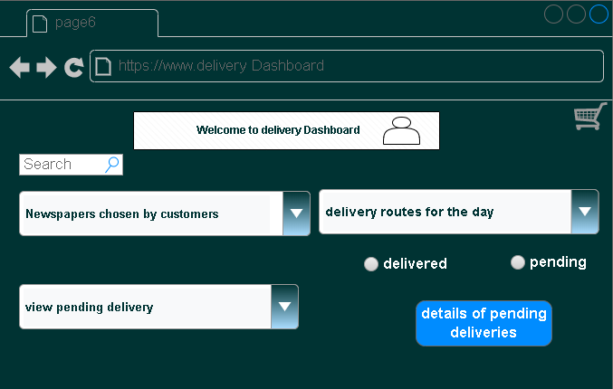

**Viewing Delivery Routes and Pending Deliveries**

**To view delivery routes and pending deliveries, log in to the system using your registered email and password. Once you are logged in, you will be directed to the delivery agent dashboard. From here, you can view the delivery routes for the day, as well as the details of pending deliveries. You can also update the status of each delivery, such as marking it as "delivered" or "pending."**